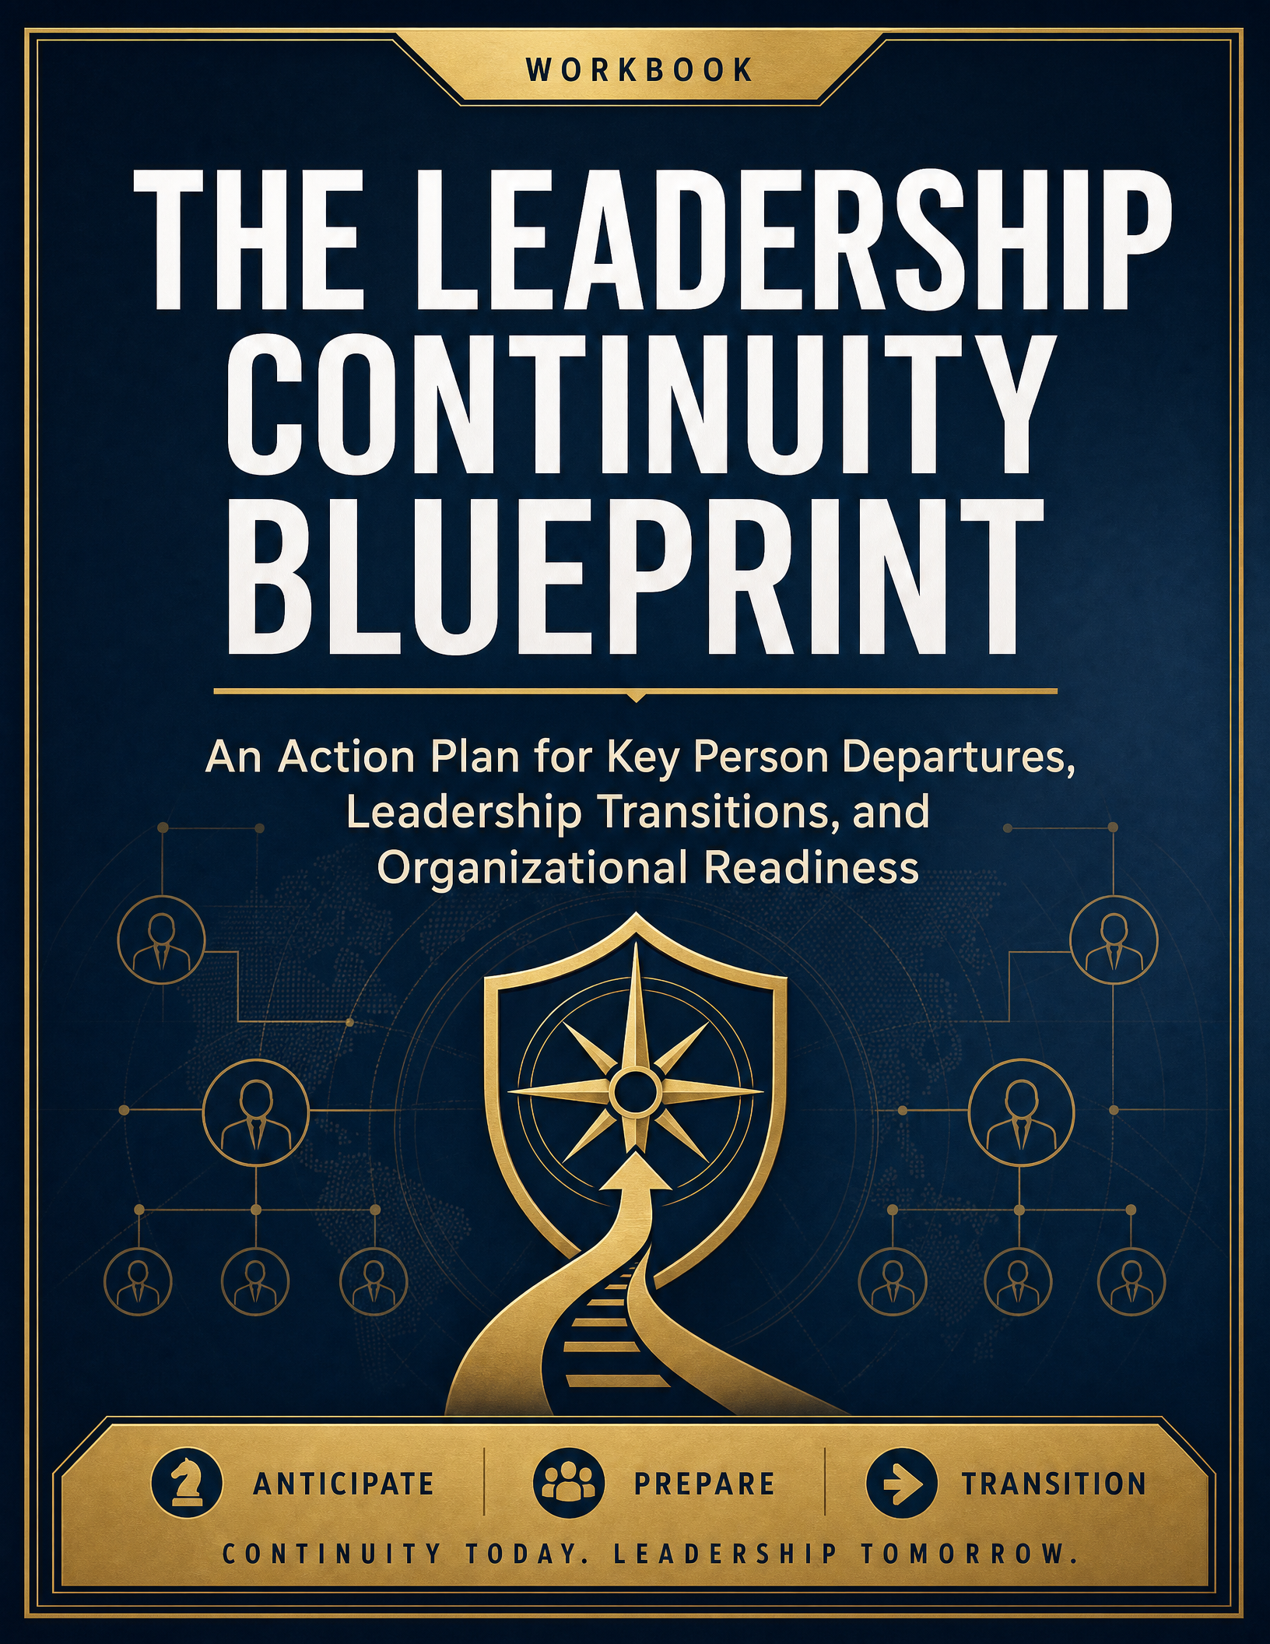

1 | WHY SUCCESSION PLANNING MATTERS  Regulatory Foundation & Strategic Intent

Succession planning is no longer optional. As of January 1, 2026, the National Credit Union Administration requires all federally insured credit unions to maintain a formal, board-approved succession plan.
This Workbook Ensures:
- Regulatory compliance
- Leadership continuity
- Reduced operational risk
- Stronger internal talent pipelines

EXERCISE 1.1 — Your Strategic Intent
Prompt: Why does succession planning matter for your specific credit union?
Our biggest leadership risk is:
Click or tap here to enter text.
If a key leader left tomorrow, the impact would be:
Click or tap here to enter text.
Click or tap here to enter text.
Our long-term strategic priorities require leaders who can:
Click or tap here to enter text.
Click or tap here to enter text.
2 | IDENTIFYING CRITICAL POSITIONS  NCUA-Required Roles & Risk Assessment

NCUA Requirement — You Must Include:
- Board of Directors
- CEO
- Senior Executive Officers
- Management Officials
- Assistant Management Officials
- Other critical personnel (board-defined)

EXERCISE 2.1 — Critical Role Identification
Position Title | Incumbent | Critical? (Y/N) | Why Critical? | Risk Level (Low/Med/High)
Enter text. | Enter text. | Enter text. | Enter text. | Enter text.
Enter text. | Enter text. | Enter text. | Enter text. | Enter text.
Enter text. | Enter text. | Enter text. | Enter text. | Enter text.
Enter text. | Enter text. | Enter text. | Enter text. | Enter text.
Enter text. | Enter text. | Enter text. | Enter text. | Enter text.
Enter text. | Enter text. | Enter text. | Enter text. | Enter text.

EXERCISE 2.2 — “If They Left Tomorrow” Drill
For each high-risk role:
Immediate operational gap:
Click or tap here to enter text.
Decisions that would stall:
Click or tap here to enter text.
Revenue/member impact:
Click or tap here to enter text.
3 | VACANCY TIMELINES & RISK FORECASTING  Mapping When Leadership Gaps Will Occur

EXERCISE 3.1 — Leadership Timeline Mapping
Position | Expected Vacancy Date | Reason (Retirement, Term Limit, Unknown) | Urgency (1–3 yrs / Immediate)
Enter text. | Enter text. | Enter text. | Enter text.
Enter text. | Enter text. | Enter text. | Enter text.
Enter text. | Enter text. | Enter text. | Enter text.
Enter text. | Enter text. | Enter text. | Enter text.
Enter text. | Enter text. | Enter text. | Enter text.
Enter text. | Enter text. | Enter text. | Enter text.

EXERCISE 3.2 — Retirement & Readiness Reality Check
% of leadership eligible to retire in 5 years:
Click or tap here to enter text.
Roles with NO ready successor:
Click or tap here to enter text.
Click or tap here to enter text.
Roles with 1 ready successor:
Click or tap here to enter text.
Click or tap here to enter text.
4 | SUCCESSOR IDENTIFICATION  Building the Internal Talent Pipeline

EXERCISE 4.1 — Internal Talent Pipeline
Position |  | Ready Now | Ready in 1–2 Years | Ready in 3–5 Years | No Internal Candidate
Enter text. |  | Enter text. | Enter text. | Enter text. | Enter text.
Enter text. |  | Enter text. | Enter text. | Enter text. | Enter text.
Enter text. |  | Enter text. | Enter text. | Enter text. | Enter text.
Enter text. |  | Enter text. | Enter text. | Enter text. | Enter text.
Enter text. |  | Enter text. | Enter text. | Enter text. | Enter text.
Enter text. |  | Enter text. | Enter text. | Enter text. | Enter text.
Enter text. |  | Enter text. | Enter text. | Enter text. | Enter text.
Enter text. |  | Enter text. | Enter text. | Enter text. | Enter text.
4 | LEADERSHIP BENCH STRENGTH  Scoring Organizational Readiness

EXERCISE 4.2 — Leadership Bench Strength Score
Rate each area (1–5):
Leadership depth:
Click or tap here to enter text.
Skill readiness:
Click or tap here to enter text.
Cultural alignment:
Click or tap here to enter text.
Decision-making capability:
Click or tap here to enter text.
TOTAL SCORE: ______ / 20

SECTION 5: LEADERSHIP DEVELOPMENT PLAN
EXERCISE 5.1 — Individual Development Plan (IDP)
Candidate Name:
Click or tap here to enter text.
Target Role:
Click or tap here to enter text.
Current Strengths:
Click or tap here to enter text.
Click or tap here to enter text.
Development Gaps:
Click or tap here to enter text.
Click or tap here to enter text.
5 | DEVELOPMENT ACTION PLAN  From Individual Plans to Org-Wide Strategy

Action Plan
Development Area | Action | Timeline | Owner
Enter text. | Enter text. | Enter text. | Enter text.
Enter text. | Enter text. | Enter text. | Enter text.
Enter text. | Enter text. | Enter text. | Enter text.
Enter text. | Enter text. | Enter text. | Enter text.
Enter text. | Enter text. | Enter text. | Enter text.

EXERCISE 5.2 — Organizational Development Strategy
What leadership skills are missing across the organization?
Click or tap here to enter text.
Click or tap here to enter text.
What training programs are needed?
Click or tap here to enter text.
Click or tap here to enter text.
How will mentoring be structured?
Click or tap here to enter text.
Click or tap here to enter text.
6 | RECRUITMENT STRATEGY  Sourcing External Talent When Needed

EXERCISE 6.1 — External Talent Plan
When internal candidates are not available:
Key External Sources:
- Industry networks
- Executive search firms
- Internal referrals
Ideal Candidate Profile:
Skills:
Click or tap here to enter text.
Experience:
Click or tap here to enter text.
Cultural fit:
Click or tap here to enter text.
Click or tap here to enter text.
7 | EMERGENCY SUCCESSION PLAN  Immediate Replacement Protocol

EXERCISE 7.1 — Immediate Replacement Protocol
For each key role:
Position |  | Interim Successor | Time Coverage | Key Responsibilities
Enter text. |  | Enter text. | Enter text. | Enter text.
Enter text. |  | Enter text. | Enter text. | Enter text.
Enter text. |  | Enter text. | Enter text. | Enter text.
Enter text. |  | Enter text. | Enter text. | Enter text.
Enter text. |  | Enter text. | Enter text. | Enter text.
Enter text. |  | Enter text. | Enter text. | Enter text.
7 | CRISIS SCENARIO PLANNING  Stress-Testing Your Emergency Response

EXERCISE 7.2 — Crisis Scenario Planning
Scenario: CEO leaves unexpectedly
Who steps in immediately?
Click or tap here to enter text.
What decisions must be made in 72 hours?
Click or tap here to enter text.
Click or tap here to enter text.
Who Communicates With:
Staff:
Click or tap here to enter text.
Board:
Click or tap here to enter text.
Members:
Click or tap here to enter text.

SECTION 8: BUDGET IMPACT ANALYSIS
EXERCISE 8.1 — Cost Planning
Category |  | Estimated Cost
Enter text. |  | Enter text.
Enter text. |  | Enter text.
Enter text. |  | Enter text.
Enter text. |  | Enter text.
8 | ROI & BOARD GOVERNANCE  Justifying Investment & Oversight

EXERCISE 8.2 — ROI of Succession Planning
Cost of NOT having a plan:
Click or tap here to enter text.
Risk reduction value:
Click or tap here to enter text.
Strategic growth impact:
Click or tap here to enter text.

SECTION 9: BOARD GOVERNANCE & APPROVAL
EXERCISE 9.1 — Board Responsibilities Checklist
☐ Approves written plan
☐ Reviews every 24 months
☐ Defines critical roles
☐ Oversees CEO succession

EXERCISE 9.2 — Board Readiness
Do all board members understand the plan?
Click or tap here to enter text.
Are new members trained within 6 months?
Click or tap here to enter text.
Is succession a standing agenda item?
Click or tap here to enter text.
10 | IMPLEMENTATION ROADMAP  The 12-Month Action Plan

Translate every exercise in this workbook into a concrete quarterly commitment. Assign a single accountable owner to each action and track status at every board review.
EXERCISE 10.1 — 12-Month Action Plan
Quarter | Priority Action | Owner | Status
Q1 | Enter text. | Enter text. | Enter text.
Q2 | Enter text. | Enter text. | Enter text.
Q3 | Enter text. | Enter text. | Enter text.
Q4 | Enter text. | Enter text. | Enter text.

Key Milestones to Watch
- Board review and formal approval of the written plan
- Completion of individual development plans for all identified successors
- Emergency succession protocol tested via tabletop exercise
- Budget for recruitment, training, and interim leadership finalized
Notes:
Click or tap here to enter text.
Click or tap here to enter text.
Click or tap here to enter text.
Click or tap here to enter text.
11 | REVIEW & COMPLIANCE TRACKING  Confirming Your Plan Meets NCUA Requirements

EXERCISE 11.1 — Compliance Checklist
☐ Written plan completed
☐ Board-approved
☐ Covers all required roles
☐ Includes emergency planning
☐ Includes budget impact
☐ Review scheduled within 24 months

SECTION 12: FINAL DELIVERABLE — YOUR SUCCESSION PLAN SUMMARY
Executive Summary Template
Credit Union Name:
Click or tap here to enter text.
Key Risks Identified:
Click or tap here to enter text.
Click or tap here to enter text.
Top 3 Critical Roles:
Click or tap here to enter text.
Click or tap here to enter text.
Click or tap here to enter text.
Successor Readiness Summary:
Ready now:
Click or tap here to enter text.
Developing:
Click or tap here to enter text.
External needed:
Click or tap here to enter text.
Board Approval Date:
Click or tap here to enter text.

